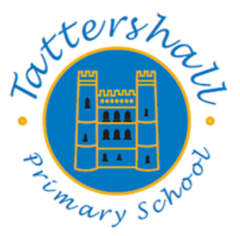

Long Term Planning
Music

Knowledge and Skills Progression

Music

Music
Curriculum Intent

The intention of the music curriculum at Tattershall Primary School is first and foremost to develop children’s musicality help children to feel that they are musical, and to develop a life-long love of music. We focus on developing the skills, knowledge and understanding that children need in order to become confident performers, composers, and listeners. Our curriculum introduces children to music from all around the world and across generations, teaching children to respect and appreciate the music of all traditions and communities.
Children will develop the musical skills of singing, playing tuned and untuned instruments, improvising and composing music, and listening and responding to music. They will develop an understanding of the history and cultural context of the music that they listen to and learn how music can be written down. Through music, our curriculum helps children develop transferable skills such as team-working, leadership, creative thinking, problem-solving, decision-making, and presentation and performance skills. These skills are vital to children’s development as learners and have a wider application in their general lives outside and beyond school.
Kapow Primary’s Music scheme of work enables pupils to meet the end of key stage attainment targets outlined in the National curriculum and the aims of the scheme align with those in the National curriculum.

Music
Curriculum Implementation
Kapow Primary’s Music scheme takes a holistic approach to music, in which the individual strands below are woven together to create engaging and enriching learning experiences:
● Listening and evaluating
● Creating sound
● Notation
● Improvising and composing
● Performing

Each five-lesson unit combines these strands within a cross-curricular topic designed to capture pupils’ imagination and encourage them to explore music enthusiastically. Over the course of the scheme, children will be taught how to sing fluently and expressively, and play tuned and untuned instruments accurately and with control. They will learn to recognise, demonstrate and name the interrelated dimensions of music - pitch, duration, tempo, timbre, structure, texture and dynamics - and use these expressively in their own improvisations and compositions.
Our National curriculum coverage shows which of our units cover each of the National curriculum attainment targets as well as each of the strands.

Our Progression of knowledge and skills shows the skills that are taught within each year group and how these skills develop to ensure that attainment targets are securely met by the end of each key stage. The Kapow Primary scheme follows the spiral curriculum model where previous skills and knowledge are returned to and built upon. Children progress in terms of tackling more complex tasks and doing more simple tasks better, as well as developing understanding and knowledge of the history of music, staff, and other musical notations, the interrelated dimensions of music and more.

In each lesson, pupils will actively participate in musical activities drawn from a range of styles and traditions, developing their musical skills and their understanding of how music works. Lessons incorporate a range of teaching strategies from independent tasks, paired and group work as well as improvisation and teacher-led performances. Lessons are ‘hands-on’ and incorporate movement and dance elements, as well as making cross curricular links with other areas of learning.
Differentiated guidance is available for every lesson to ensure that lessons can be accessed by all pupils and opportunities to stretch pupils’ learning are available when required. Knowledge organisers for each unit support pupils in building a foundation of factual knowledge by encouraging recall of key facts and vocabulary.

Strong subject knowledge is vital for staff to be able to deliver a highly effective and robust music curriculum. Each unit of lessons includes multiple teacher videos to develop subject knowledge and support ongoing CPD, aiding teachers in their own acquisition of musical skills and knowledge. Further CPD opportunities can also be found via webinars with our music subject specialists. Kapow has been created with the understanding that many teachers do not feel confident delivering the music curriculum and every effort has been made to ensure that they feel supported to deliver lessons of a high standard that ensure pupil progression.

At Tattershall Primary School music is taught discreetly from Year 1 to Year 6, mostly through a weekly lesson. Each year group is taught independently. Music lessons in year 5 and 6 will be led by The Lincolnshire Music Service. During the Autumn term they will have Whole Class Ensemble Tuition (WCET) delivered by Lincolnshire Music Service, in the spring and summer terms they will follow Kapow units led my Lincolnshire Music Service. During the summer term our year 3 and 4 children will have Whole Class Ensemble Tuition (WCET) delivered through the use of Lincolnshire Music Service video lessons.

Music
Curriculum Organisation

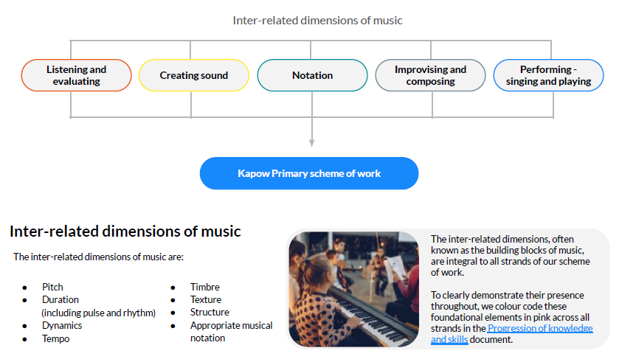

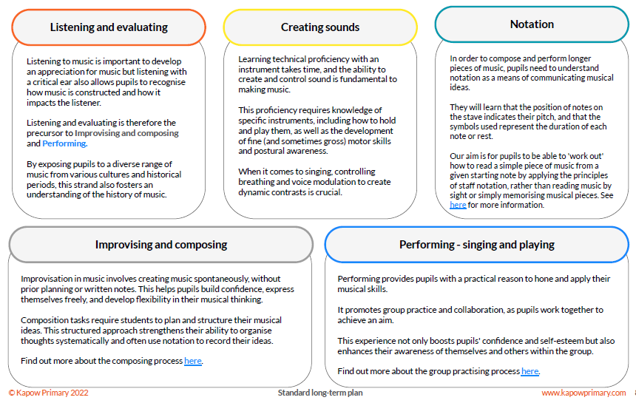

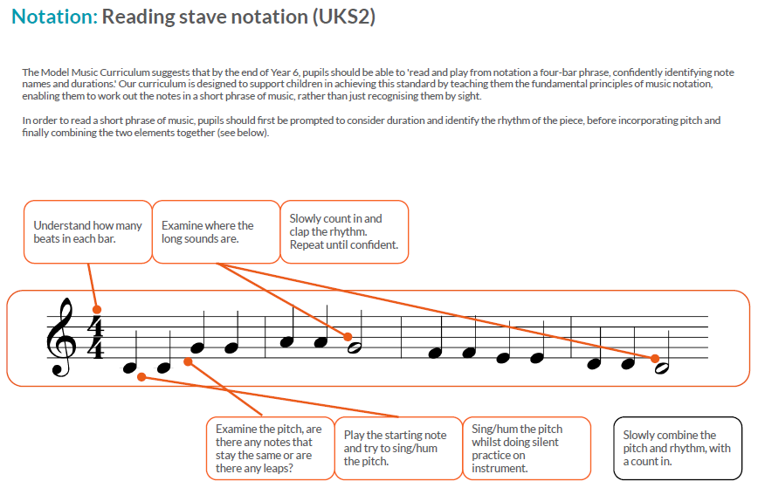
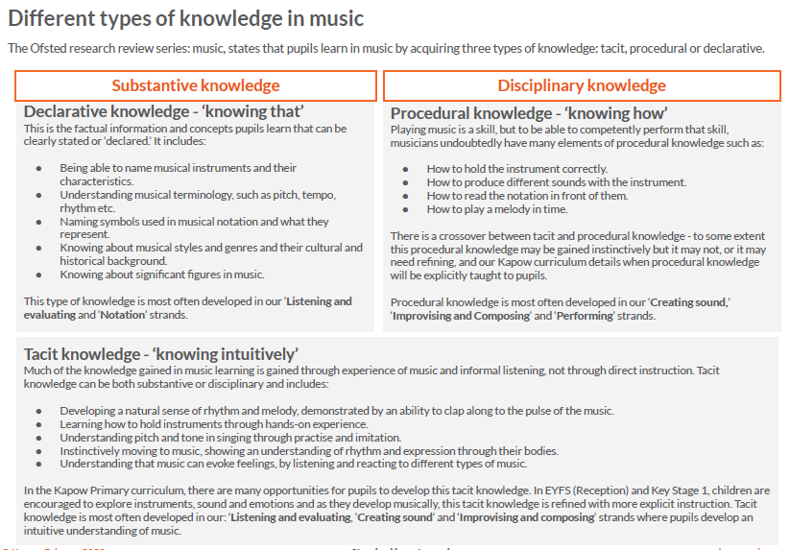

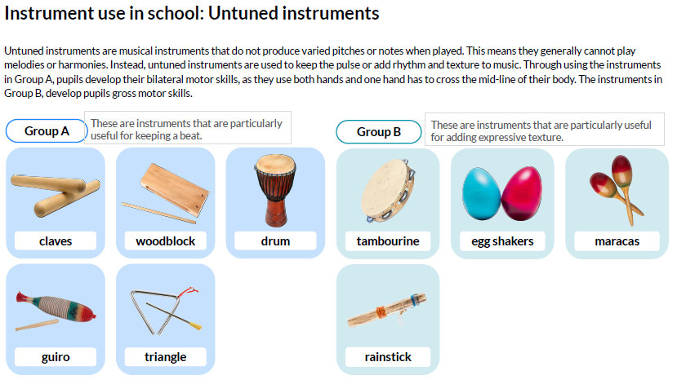

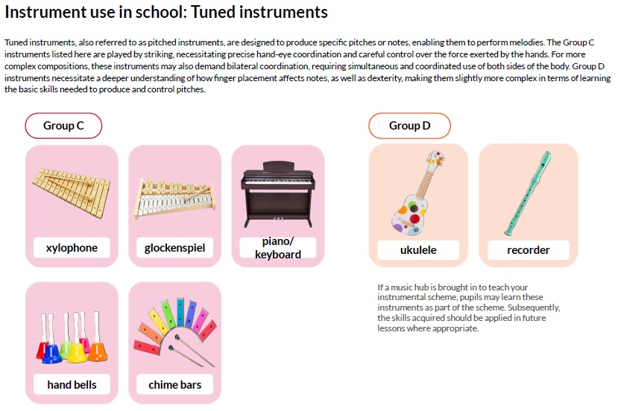
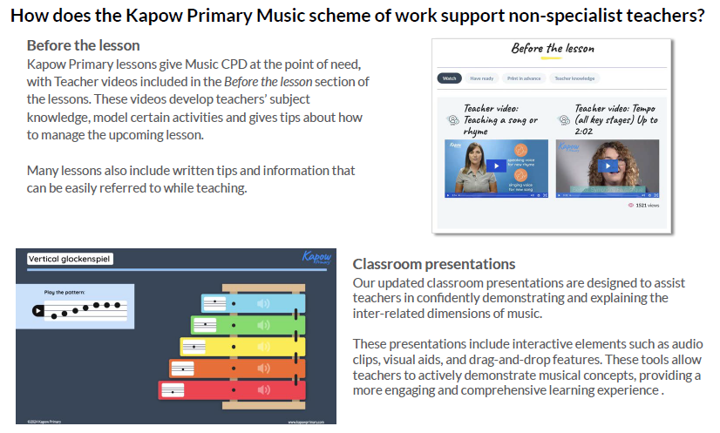

Music
Long Term Plan

 | EYFS | Year 1 | Year 2 | Year 3 | Year 4 | Year 5 | Year 6
Autumn 1 | ‘Exploring sound’  Exploring how we can use our voice, bodies and instruments to make  sounds, and identifying sounds in the environment. | ‘Keeping the pulse (My favourite things)’  Exploring the concept of keeping a steady pulse together, children  engage in music and movement activities inspired by their favourite  things. They participate in different activities, moving to the beat of the music while thinking about and expressing their favourite objects or experiences. | ‘Call and response (Animals)’  Chanting different call and response sound patterns, children  progress to creating their own call and response patterns using  untuned percussion instruments. They practise rhythm and pulse as  they echo and respond to each other's chants, building a strong sense  of musical communication. | ‘Ballads’  Learning what ballads are, how to identify their features and how to  convey different emotions when performing… Selecting vocabulary  to describe a story, before turning it into lyrics following the  structure of a traditional ballad. | ‘Body and tuned percussion (Theme: Rainforests)’  Exploring the rainforest through music whilst being introduced to  new musical terms. Using a mixture of body percussion and tuned  percussion instruments to create rhythms of the rainforest, layer by  layer. | ‘Brass’  Whole Class Ensemble Tuition (WCET) delivered by Lincolnshire Music Service | ‘Brass’  Whole Class Ensemble Tuition (WCET) delivered by Lincolnshire Music Service
Autumn 2 | ‘Celebration music’  Learning about the music from a range of cultural and religious  celebrations, including Diwali, Hanukkah, Kwanzaa and Christmas. | ‘Tempo (Theme: Snail and mouse)’  Using voices, bodies and instruments to listen and respond to different  pieces of music, children learn and perform a rhyme and song with a focus  on tempo. They focus on the adventures of the Snail and mouse to  understand how tempo can shape a musical story, | ‘Instruments (Musical storytelling)’  Exploring longer pieces of music, children look at how music can tell a  story through the use of different instruments. They think creatively,  considering how sounds can represent characters, actions, and emotions  when creating a soundscape to tell the story of Jack and the Beanstalk. | ‘Creating compositions in response to an animation (Theme: Mountains)’  Listening to music and considering the narrative it represents by paying  close attention to the dynamics, pitch and tempo and how they change  throughout the piece. Creating original compositions to match an  animation. | ‘Rock and Roll’  Learning about the origin and features of rock and roll music, playing the  Hand Jive and Rock Around the Clock, looking specifically at a walking  bass line, and performing a while-class piece. | ‘Brass’  Whole Class Ensemble Tuition (WCET) delivered by Lincolnshire Music Service | ‘Brass’  Whole Class Ensemble Tuition (WCET) delivered by Lincolnshire Music Service
Spring 1 | ‘Music and movement’  Creating simple actions to well-known songs, learning how to move to a  beat and expressing feelings and emotions through movement to music. | ‘Dynamics (Seaside)’  Exploring the connections between music, sounds, and  environments, children aim to represent the seaside. They use  percussion instruments, vocal sounds, and body percussion to create  sounds like crashing waves, calling seagulls, and rustling sand. They  use voices and instruments to practice varying dynamics—showing a  contrast between loud and soft sounds. | ‘Contrasting dynamics (Space)’  Developing knowledge and understanding of contrasting dynamics,  children listen to different pieces of music that represent planets and  use these musical examples to inspire their own compositions. They  explore how varying loud and soft sounds can capture the unique  characteristics of two different planets. | ‘Jazz’  Learning about ragtime style music, traditional jazz music and scat  singing. Children create a jazz motif using a swung rhythm and play a  jazz version of a nursery rhyme using tuned percussion. | ‘Changes in pitch, tempo and dynamics (Theme: Rivers)’  Linking to geography learning, pupils represent different stages of  the river through vocal and percussive ostinatos, culminating in a  final group performance. | ‘Blues’  Identifying the key features and mood of Blues music and its importance  and purpose. Learning the 12-bar Blues and the Blues scale, and  combining these to create an improvised piece with a familiar, repetitive  backing. | ‘Dynamics, pitch and tempo (Theme: Fingal's Cave)’  Appraising the work of Mendelssohn and further developing the  skills of improvisation and composition.
Spring 2 | ‘Musical stories’  Moving to music with instruction, changing movements to match the  tempo, pitch or dynamics and learning that music and instruments can  convey moods or represent characters. | ‘Sound patterns (Fairytales)’  Examining different favourite fairy tales, children discuss the key  moments in these stories. They are guided to clap and read simple sound  patterns, matching the different characters of the story. Pupils then use  these sound patterns to retell the fairy tale, bringing the story to life  through sound and movement. | ‘Singing (On this island)’  Learning songs and creating sounds to represent three contrasting  landscapes—seaside, countryside, and city—children explore how music  can evoke different environments. They sing folk songs to reflect the  different environments and use instruments and body percussion to  create soundscapes representing one of the environments. | ‘Pentatonic melodies and composition (Theme: Chinese New Year)’  Using the story of Chinese New Year as a stimulus: revising key musical  terminology, playing and creating pentatonic melodies, composing a piece  of music in a group using layered melodies and performing a finished  piece. | ‘Adapting and transposing motifs (Theme: Romans)’  Drawing upon their understanding of repeating patterns in music, pupils  are introduced to the concept of motifs and adapt and transpose motifs  and perform them to their peers. | ‘Composition to represent the festival of colour (Theme: Holi festival)’  Exploring the associations between music, sounds and colour, composing  and, as a class and performing their own musical composition to represent  Holi. | ‘Film music’  Exploring and identifying the characteristics of film music. Creating a  composition and graphic score to perform alongside a film.
Summer 1 | ‘Transport’  Identifying and copying sounds produced by different vehicles using  voices, bodies and instruments, demonstrating tempo changes and  understanding how symbols can represent sound. | ‘Pitch (Superheroes)’  Identifying high and low notes, children use this knowledge to  compose a simple tune that represents a superhero. They then listen  to different pitches, recognising the difference between high and low  sounds. After identifying these notes, pupils experiment with  combining different pitches to create a melody that represents their  chosen superhero. | ‘Structure (Myths and legends)’  Exploring structure through listening, analysing, and performing,  children engage with a song about a well-known myth to understand  its composition. They listen to identify sections, analyse simple sound  patterns, and see how these elements tell the story of the myth.  Pupils then perform short sound patterns in a simple structure using  instruments and voices. | ‘Djembe Drumming’  Whole Class Ensemble Tuition (WCET) delivered through the use of Lincolnshire Music Service video lessons | ‘Djembe Drumming’  Whole Class Ensemble Tuition (WCET) delivered through the use of Lincolnshire Music Service video lessons | ‘Blues’  Identifying the key features and mood of Blues music and its importance  and purpose. Learning the 12-bar Blues and the Blues scale, and  combining these to create an improvised piece with a familiar, repetitive  backing. | ‘Theme and Variations (Theme: Pop Art)’  Exploring the musical concept of theme and variations and discovering  how rhythms can 'translate’ onto different instruments
Summer 2 | ‘Big band’  Learning about what makes a musical instrument, the four different  groups of musical instruments, following a beat using an untuned  instrument and performing a practised song. | ‘Musical symbols (Under the sea)’  Diving into the unknown, children explore the depths of the sea through  music, movement, musical symbols, and the playing of tuned percussion  instruments. They engage in activities that allow them to express the  mysterious underwater world, such as using their bodies to mimic the  movement of sea creatures. They learn to interpret musical symbols to  translate visual cues into sounds and play tuned percussion instruments,  to represent the wonders of the underwater world. | ‘Pitch (Musical Me)’  Learning to sing and play the song ‘Once a Man Fell in a Well,’ children  learn to connect the melody to specific pitches. They explore how  different notes correspond to different parts of the song, using their  instruments to recreate the tune accurately. Additionally, they begin to  recognise how simple symbols can represent pitch, developing their  ability to read and interpret musical notation. | ‘Samba Drumming’  Whole Class Ensemble Tuition (WCET) delivered through the use of Lincolnshire Music Service video lessons | ‘Samba Drumming’  Whole Class Ensemble Tuition (WCET) delivered through the use of Lincolnshire Music Service video lessons | ‘Looping and remixing’  Learning how dance music is created, focusing particularly on the use  of loops, and learning how to play a well known song before putting a  dance music spin on it to create their own versions. | ‘Composing and performing a Leavers' Song’  Creating their own leavers’ song personal to their experiences as a class;  listening to and critiquing well known songs, writing the lyrics,, exploring  the concept of the four chord backing track and composing melodies.

Progression of Knowledge and Skills
Click on the icon below to open our Music Progression of Knowledge and Skills Document

How our School Values are Embedded in Music
HONESTY FORGIVENESS KINDNESS TEAMWORK RESPECT
Honesty | Forgiveness | Kindness | Teamwork | Respect

ASSESSMENT IN MUSIC

Music
Curriculum Impact

The impact of Kapow Primary’s scheme can be constantly monitored through both formative and summative assessment opportunities. Each lesson includes guidance to support teachers in assessing pupils against the learning objectives and at the end of each unit there is often a performance element where teachers can make a summative assessment of pupils’ learning. Knowledge organisers for each unit support pupils by providing a highly visual record of the key learning from the unit, encouraging recall of practical skills, key knowledge and vocabulary.
After the implementation of Kapow Primary Music, pupils should leave primary school equipped with a range of skills to enable them to succeed in their secondary education and to be able to enjoy and appreciate music throughout their lives.
The expected impact of following the Kapow Primary Music scheme of work is that children will:
✓ Be confident performers, composers and listeners and will be able to express themselves musically at and beyond school.
✓ Show an appreciation and respect for a wide range of musical styles from around the world and will understand how music is influenced by the wider cultural, social, and historical contexts in which it is developed.
✓ Understand the various ways in which music can be written down to support performing and composing activities.
✓ Demonstrate and articulate an enthusiasm for music and be able to identify their own personal musical preferences.
✓ Meet the end of key stage expectations outlined in the National curriculum for Music.

